NAME DATE PERIOD
Historical Thinking Skill: Comparison
Analyze the document set to determine the distinction between the Chesapeake and New England settlements. Use specific information from the ships’ lists and the documents.

TRAIT | CHESAPEAKE | NEW ENGLAND
Motives for settlement

Settler Demographics: Age

Economics/
Occupations

Social Patterns

Religion

Labor Systems

Doc 1

SHIPS LIST BOUND FOR Weymouth, MA 1635
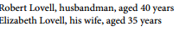
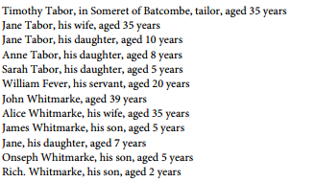
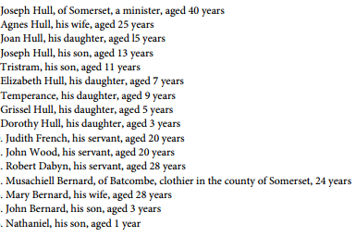

Doc 2
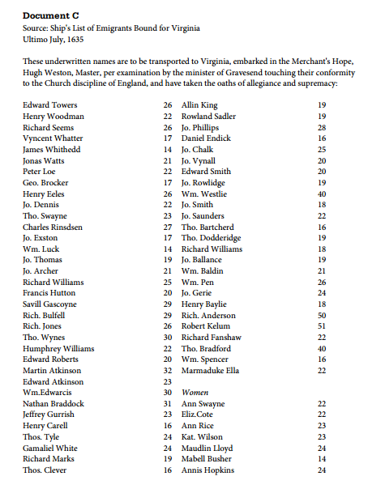

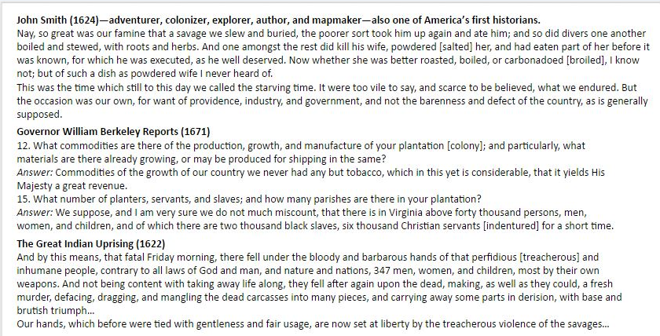
Doc 3
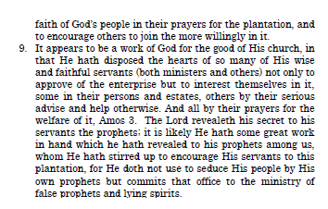
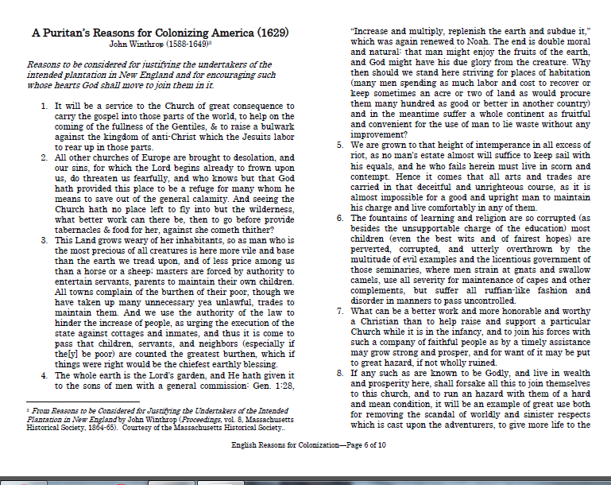
Doc 4

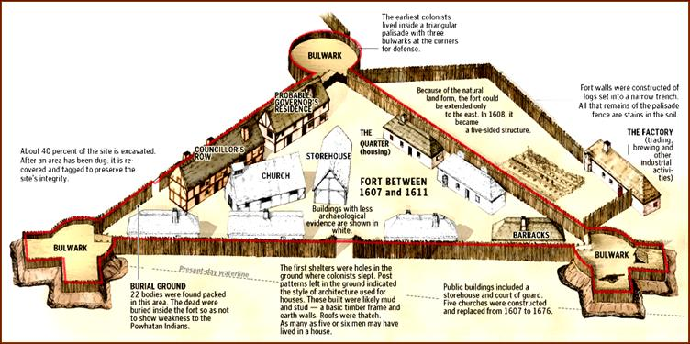
Doc 5 - Jamestown settlement, 1607
Source: http://www.latinamericanstudies.org/jamestown.htm

Doc 6
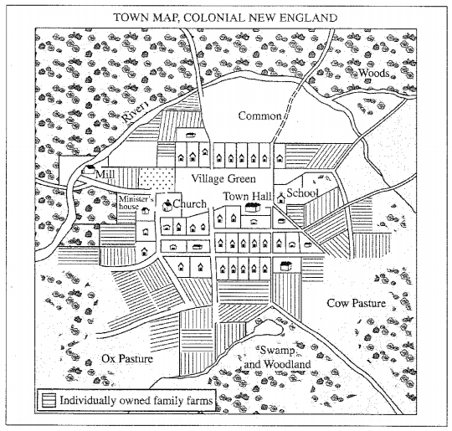

Doc 7

“Mayflower Compact”

Agreement Between the Settlers at New Plymouth: 1620
IN THE NAME OF GOD, AMEN. We, whose names are underwritten, the Loyal Subjects of our dread Sovereign Lord King James, by the Grace of God, of Great Britain, France, and Ireland, King, Defender of the Faith, &c. Having undertaken for the Glory of God, and Advancement of the Christian Faith, and the Honour of our King and Country, a Voyage to plant the first Colony in the northern Parts of Virginia; Do by these Presents, solemnly and mutually, in the Presence of God and one another, covenant and combine ourselves together into a civil Body Politick, for our better Ordering and Preservation, and Furtherance of the Ends aforesaid: And by Virtue hereof do enact, constitute, and frame, such just and equal Laws, Ordinances, Acts, Constitutions, and Officers, from time to time, as shall be thought most meet and convenient for the general Good of the Colony; unto which we promise all due Submission and Obedience. IN WITNESS whereof we have hereunto subscribed our names at Cape-Cod the eleventh of November, in the Reign of our Sovereign Lord King James, of England, France, and Ireland, the eighteenth, and of Scotland the fifty-fourth, Anno Domini; 1620.
Mr. John Carver,
Mr. William Bradford,
Mr Edward Winslow,
Mr. William Brewster.
Isaac Allerton,
Myles Standish,
John Alden,
John Turner,
Francis Eaton,
James Chilton,
John Craxton,
John Billington,
Joses Fletcher,
John Goodman,
Mr. Samuel Fuller,
Mr. Christopher Martin,
Mr. William Mullins,
Mr. William White,
Mr. Richard Warren,
John Howland,
Mr. Steven Hopkins,.
Digery Priest,
Thomas Williams,
Gilbert Winslow,
Edmund Margesson,
Peter Brown,
Richard Britteridge
George Soule,
Edward Tilly,
John Tilly,
Francis Cooke,
Thomas Rogers,
Thomas Tinker,
John Ridgdale
Edward Fuller,
Richard Clark,
Richard Gardiner,
Mr. John Allerton,
Thomas English,
Edward Doten,
Edward Liester

Source:
The Federal and State Constitutions Colonial Charters, and Other Organic Laws of the States, Territories, and Colonies Now or Heretofore Forming the United States of America
Compiled and Edited Under the Act of Congress of June 30, 1906 by Francis Newton Thorpe
Washington, DC : Government Printing Office, 1909.

Doc 8

Lawes Devine, Morall and Martiall, etc
Issued in Jamestown 1610-1611

